SQL commands

Create table(name datatype constraint,…)

Insert into table_name(column1, column2…)

Values( column1, column2…)

Alter table table_name

Change column name

Alter table table_name

Modify column datatype

Create table drugs( DID numbers primary key, genename varchar(30) not null, brandname varchar(25) not null, dosage varchar(8) not null)

Create table organizations(OID number primary key, oname varchar(55) not null, oaddress varchar(30) not null, ocity varchar(20) not null, ostate varchar(2) not null, ozip varchar(6) not null)

Create table allergies( AID number primary key, PTID numbers, foreign Key(PTID) references Patients(PTID), DID numbers, foreign key(DID) references Drugs(DID))

Create table prescribers( NYSPL varchar(8) primary key, pfname varchar(20) not null, plname varchar(20) not null, addres varchar(25) not null, city varchar(20) not null, state varchar(2) not null, zcode varchar(5) not null)

Create table patients(PTID number primary key, pfirst varchar(20) not null, plast varchar(25) not null, address varchar(30) not null, city varchar(20) not null, state varchar(2) not null, zcode varchar(5) not null, phone varchar(15) not null, email varchar(30) not null, PMID number, foreign key(PMID) references Pharmacies(PMID))

Create table pharmacies(PMID number primary key, pname varchar(40) not null, address varchar(20) not null, city varchar(15) not null, state varchar(2) not null, zip varchar(5) not null, phone varchar(15) not null)

1. Identify the most popular medication prescribed in New York in the last year. Display the drug name and number prescribed. Display one row for each drug. Order alphabetically by drug name.

select genename as Drug_Name, count(1) as Number_Precribed

from drugs, prescriptions, prescribers

where prescriptions.dop >'04-13-2015' and drugs.did = prescriptions.did and prescribers.city = 'New York' and prescribers.nyspl = prescriptions.nyspl

group by genename

order by genename

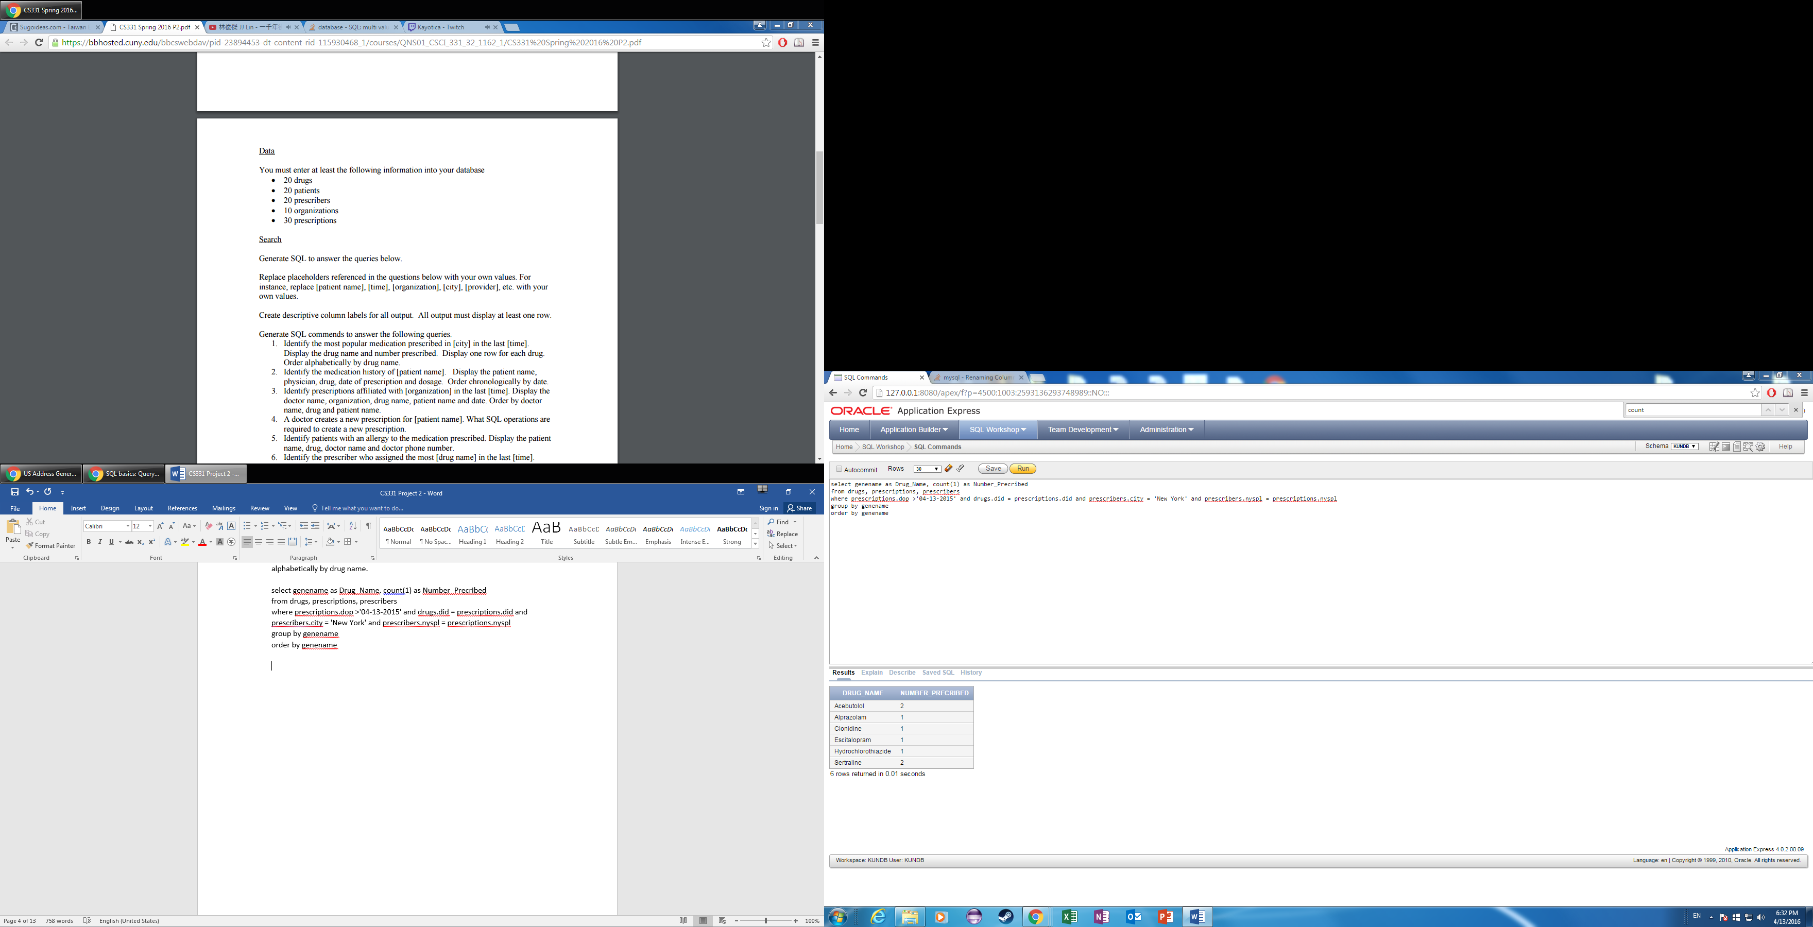

1. Identify the medication history of Patrick Orenstein. Display the patient name, physician, drug, date of prescription and dosage. Order chronologically by date.

select pfirst || ' ' || plast as Patient_Name, pfname|| ' ' || plname as Physician, genename as Drug_Name, dop as Date_Of_Prescription, dosage

from drugs, prescriptions, prescribers, patients

where drugs.did = prescriptions.did and prescribers.nyspl = prescriptions.nyspl and patients.pfirst = 'Patrick' and patients.plast = 'Orenstein' and prescriptions.ptid = patients.ptid

order by DOP

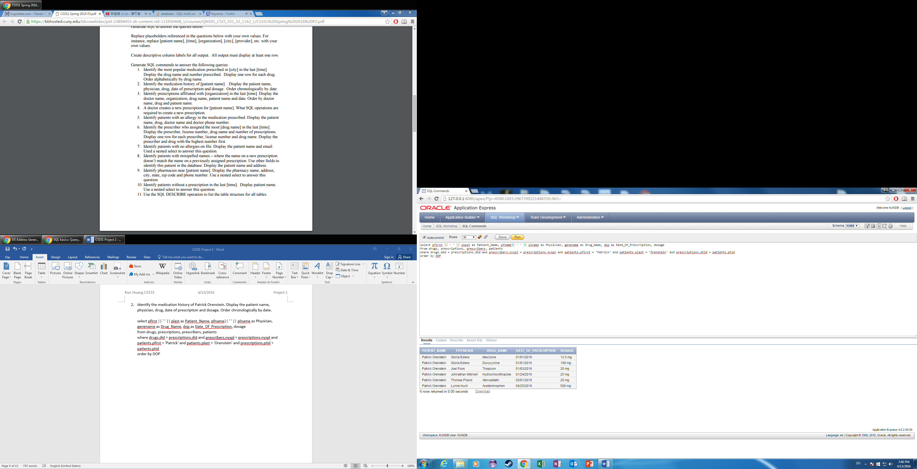

1. Identify prescriptions affiliated with CityMD in the since the beginning of the year, 2016. Display the doctor name, organization, drug name, patient name, and date. Order by doctor name, drug, and patient name.

select pfname|| ' ' || plname as Doctor_Name, oname as Organizations, genename as Drug_Name, pfirst || ' ' || plast as Patient_Name, dop as Date_Of_Prescription

from organizations, prescribers, multiinfo, drugs, prescriptions, patients

where multiinfo.nyspl = prescribers.nyspl and organizations.oname = 'CityMD' and multiinfo.oid = organizations.oid and prescriptions.nyspl = prescribers.nyspl and drugs.did = prescriptions.did and patients.ptid = prescriptions.ptid and dop > '01-01-2016'

order by Doctor_Name, Drug_Name, Patient_Name

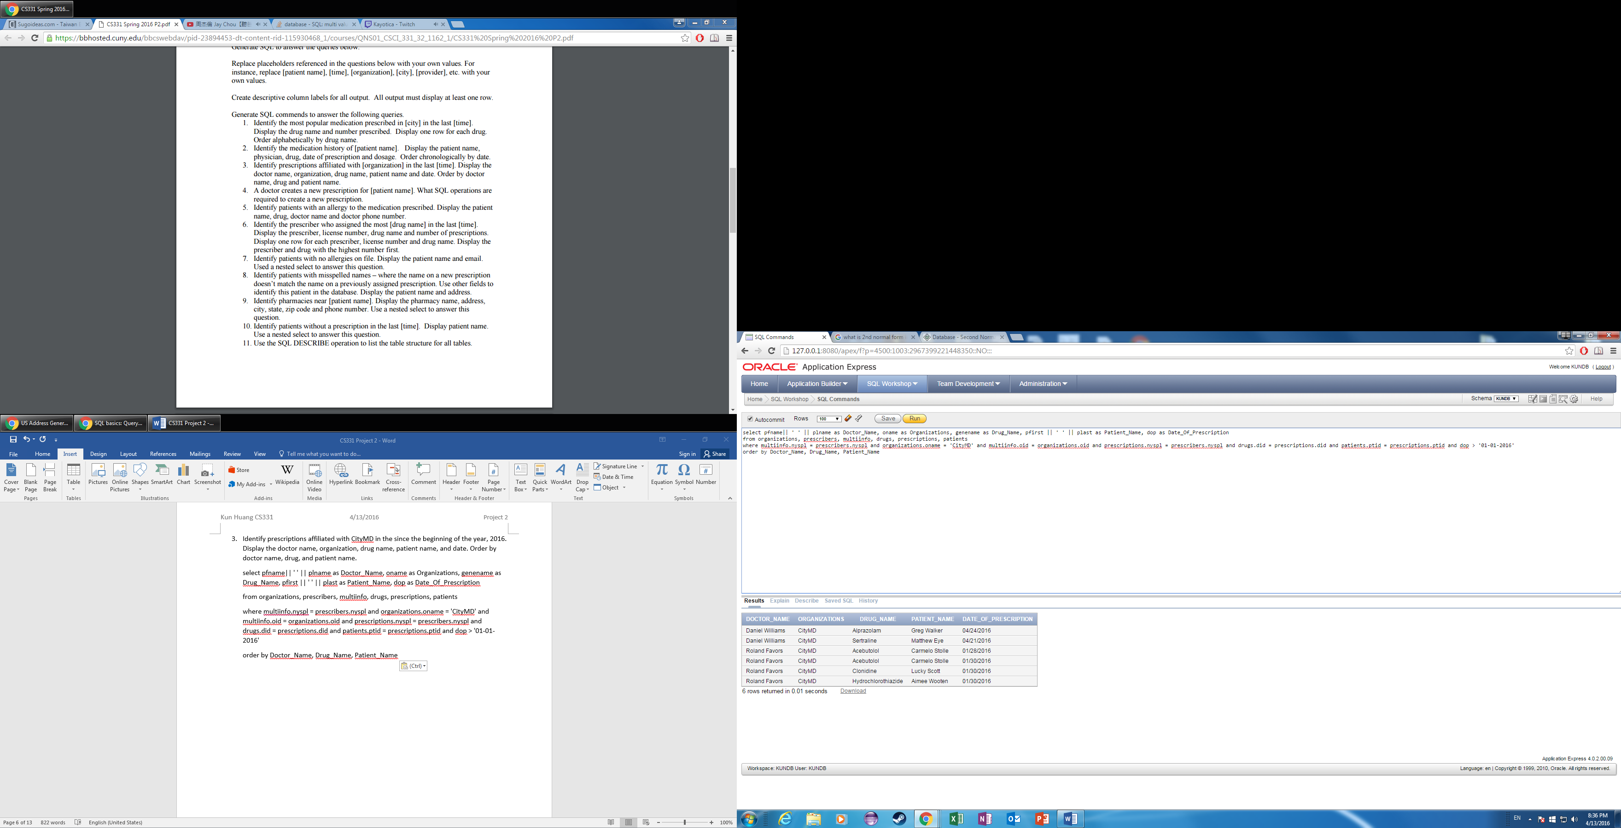

1. A doctor creates a new prescription for [patient name]. What SQL operations are required to create a new prescription.

insert into prescriptions( PID, NYSPL, PTID, DOP, DID, REFILLS, FIRST, LAST)

values(32, 'Q100', 24, '10-14-2015', 320, 0, 'Matthew', 'Eye')

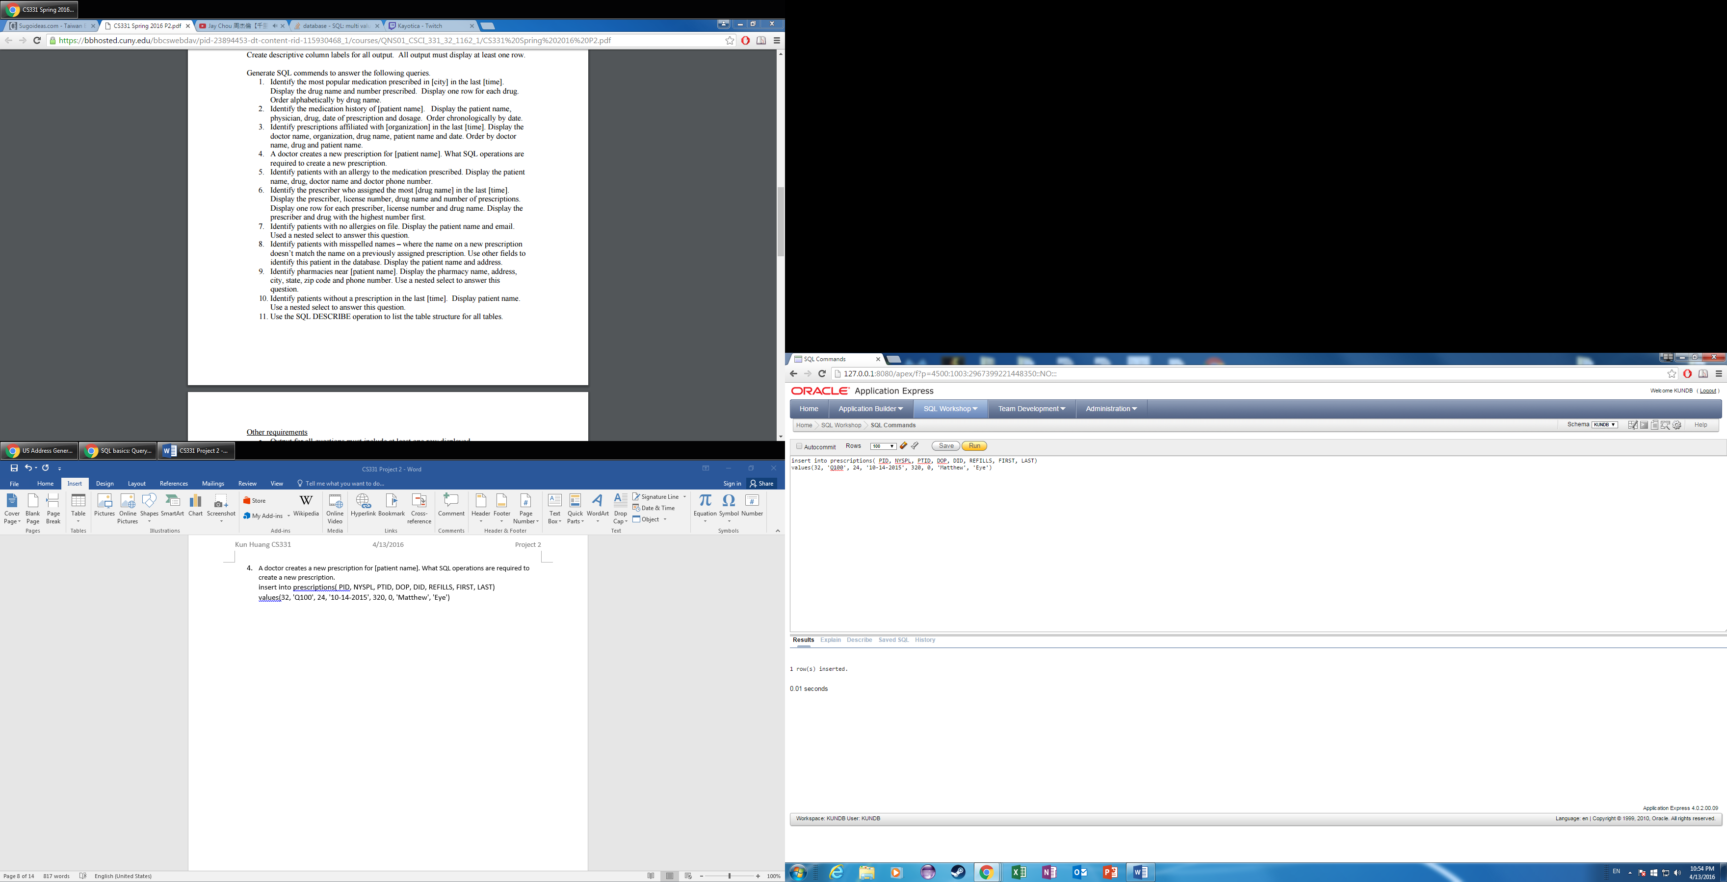

1. Identify patients with an allergy to the medication prescribed. Display the patient name, drug, doctor name and doctor phone number

select pfirst|| ' ' || plast as Patient_Name, genename as Drug, pfname|| ' ' || plname as Doctor_Name, multiinfo.phone

from patients, allergies, drugs, prescriptions, prescribers, multiinfo

where patients.ptid = allergies.ptid and prescriptions.ptid = patients.ptid and prescriptions.did = drugs.did and prescribers.nyspl = prescriptions.nyspl and multiinfo.nyspl = prescribers.nyspl

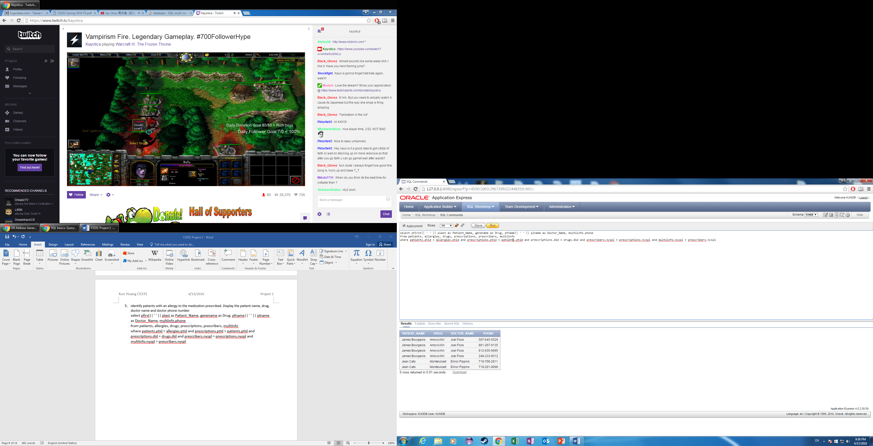

1. Identify the prescriber who assigned the most Acebutolol in the last 6 months. Display the prescriber, license number, drug name and number of prescriptions. Display one row for each prescriber, license number and drug name. Display the prescriber and drug with the highest number first.

select pfname || ' ' || plname as Prescriber, prescribers.nyspl as License_Number, genename as Drug_Name, count(1) as Number_Of_Prescriptions

from prescribers, drugs, prescriptions

where drugs.genename = 'Acebutolol' and dop > '10-13-2015' and drugs.did = prescriptions.did and prescriptions.nyspl = prescribers.nyspl

group by pfname || ' ' || plname, prescribers.nyspl, genename

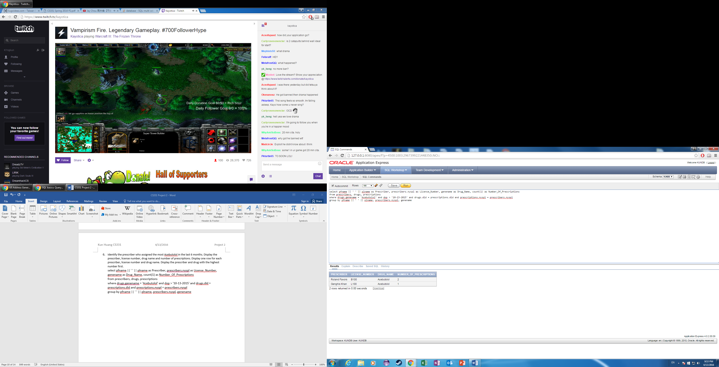

1. Identify patients with no allergies on file. Display the patient name and email. Used a nested select to answer this question

select pfirst|| ' ' || plast as Patient_Name, email as Email

from patients

where PTID not in

(select PTID

from allergies

)

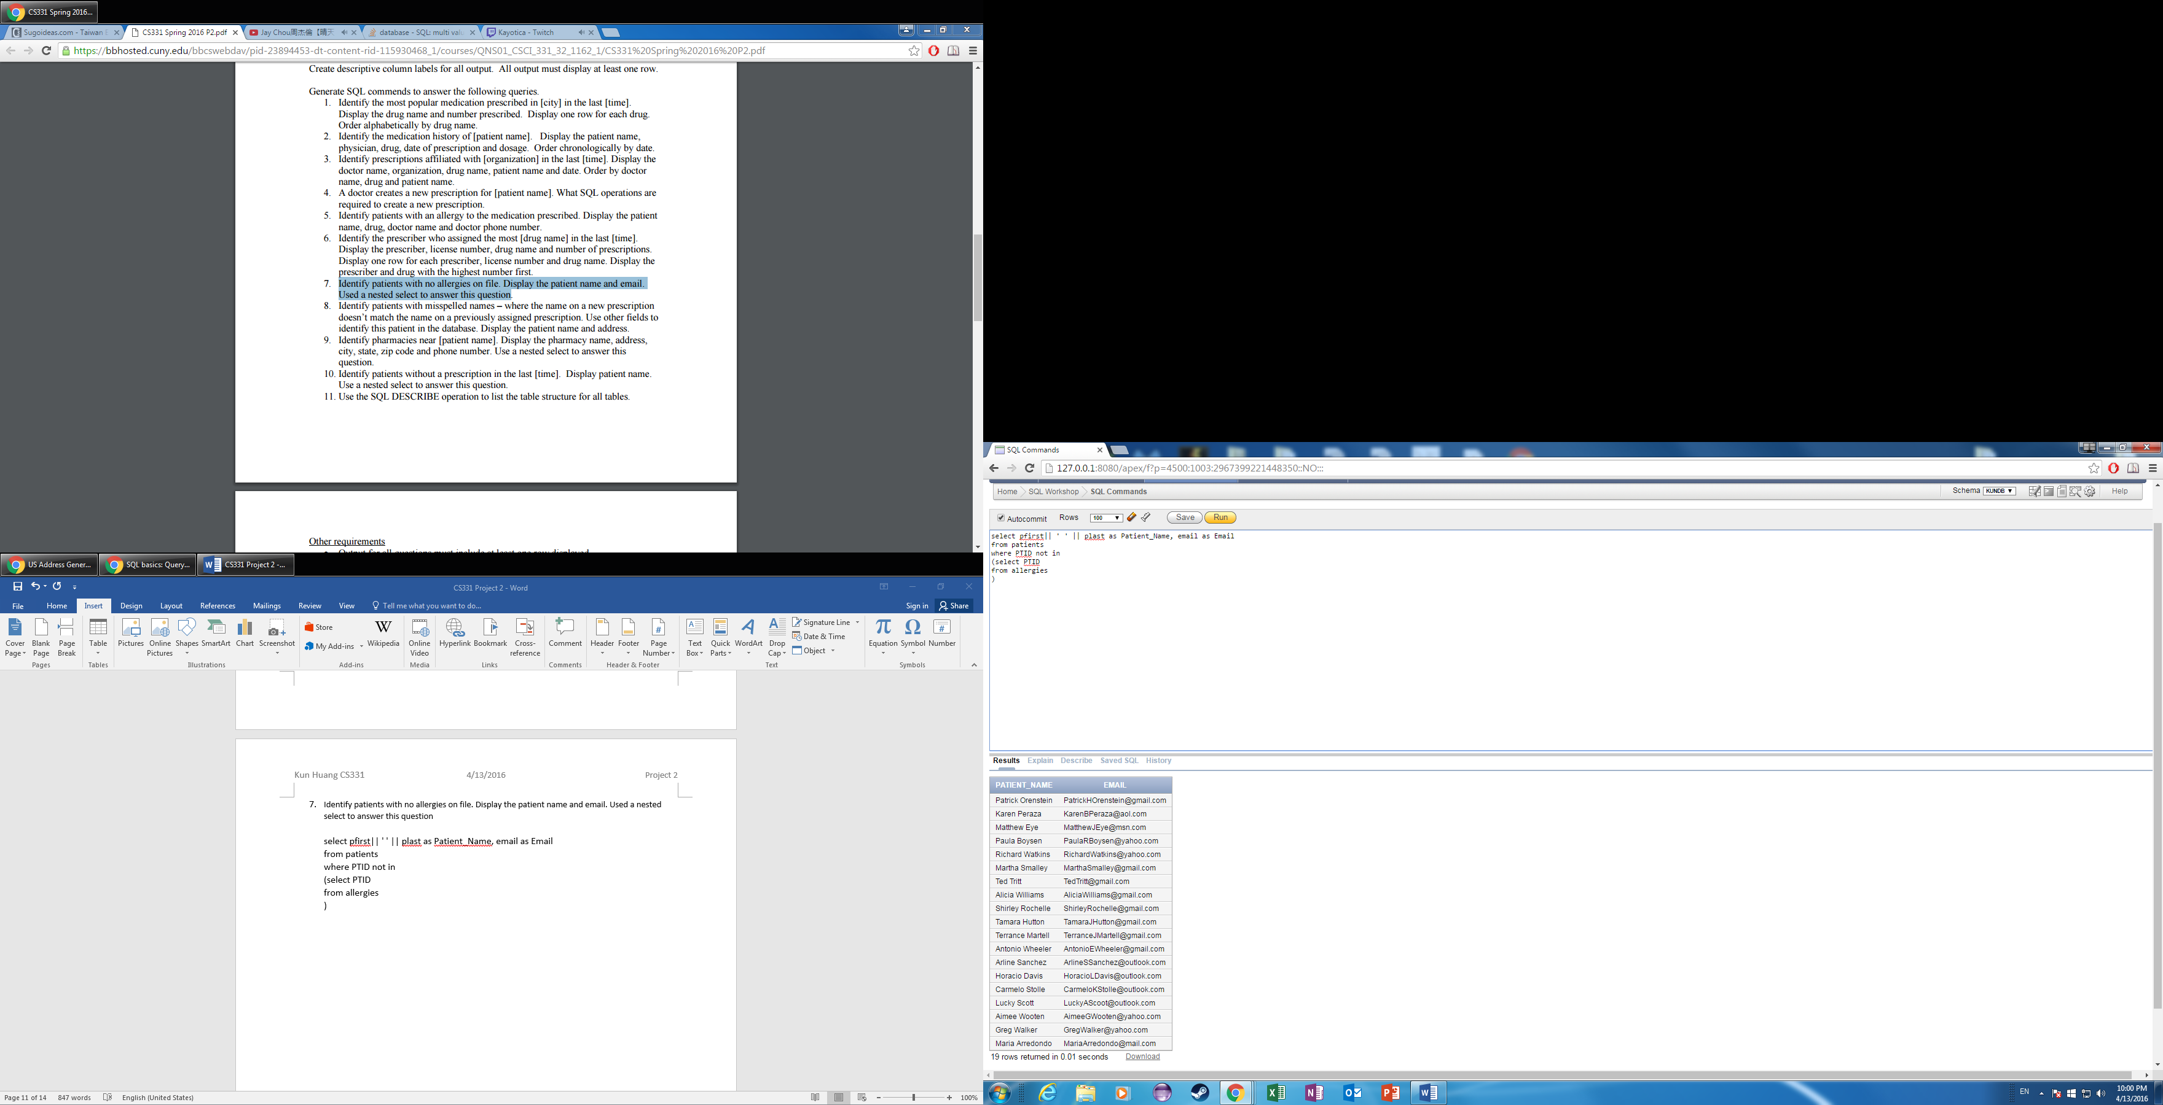

1. Identify patients with misspelled names – where the name on a new prescription doesn’t match the name on a previously assigned prescription. Use other fields to identify this patient in the database. Display the patient name and address

select pfirst||' ' || plast as Patient_Name, address as Address

from patients, prescriptions

where Prescriptions.ptid = patients.ptid and (prescriptions.first != patients.pfirst or prescriptions.last != patients.plast)

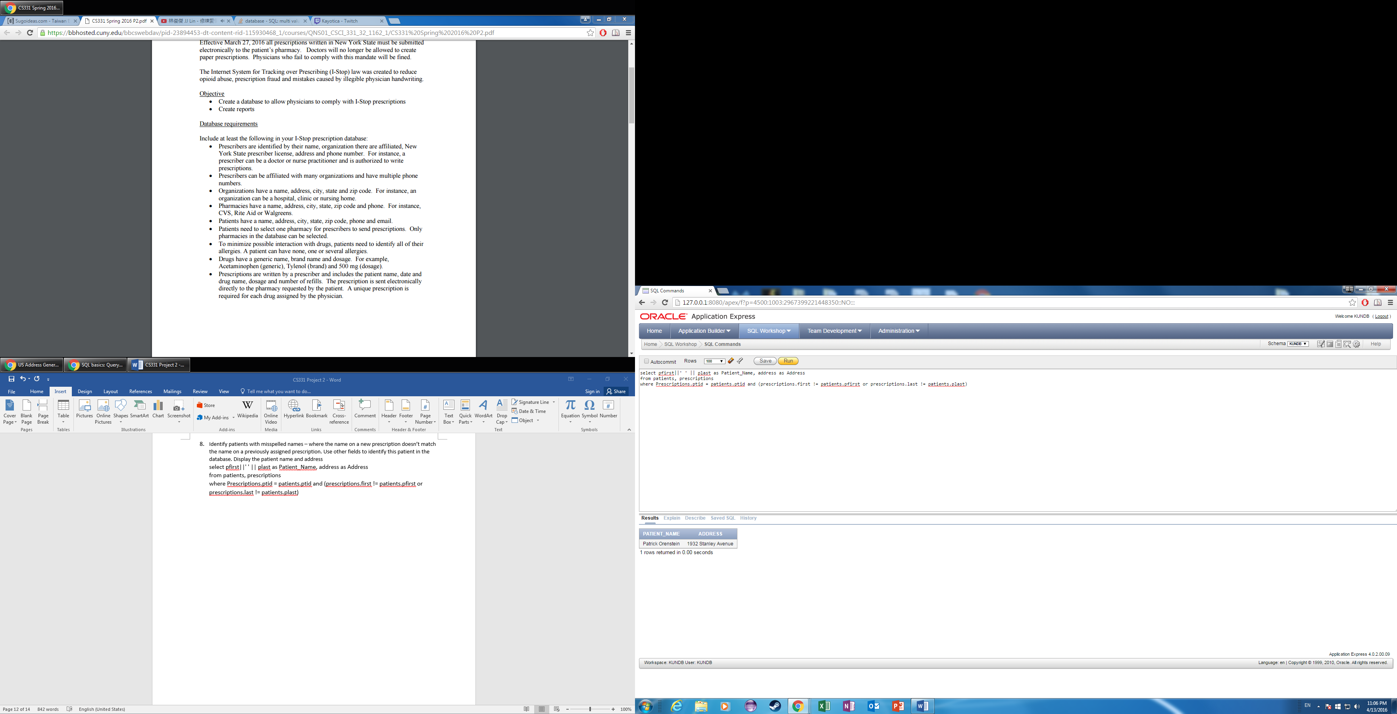

1. Identify pharmacies near Maria Arredondo. Display the pharmacy name, address, city, state, zip code and phone number. Use a nested select to answer this question.

Select pname as Pharmacy_Name, address as Address, city as City, state as State, zip as Zip_code, phone as Phone_Number

from pharmacies

where city in

(select city

from Patients

where pfirst ='Maria' and plast = 'Arredondo'

)

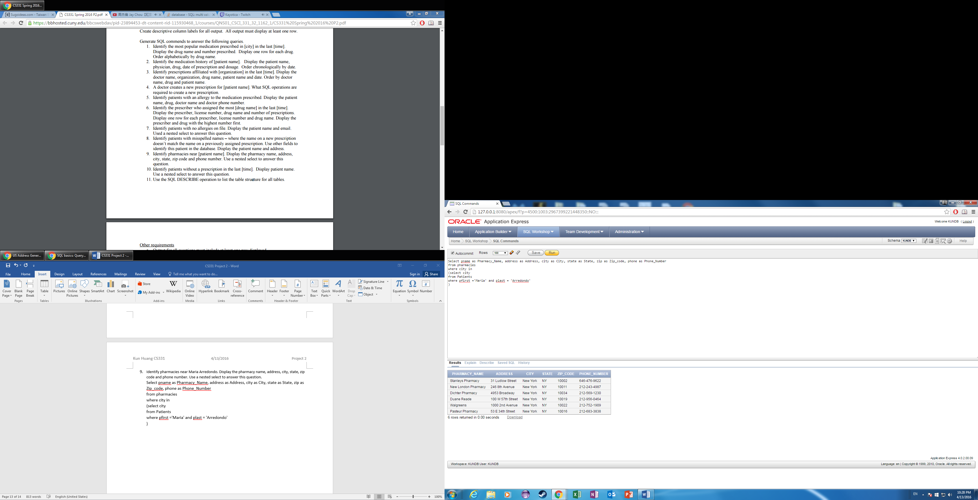

1. Identify patients without a prescription in the last 3 months. Display patient name. Use a nested select to answer this question.

Select pfirst|| ' ' || plast as Patient_Name

from patients

where PTID not in

(select PTID

from Prescriptions

)

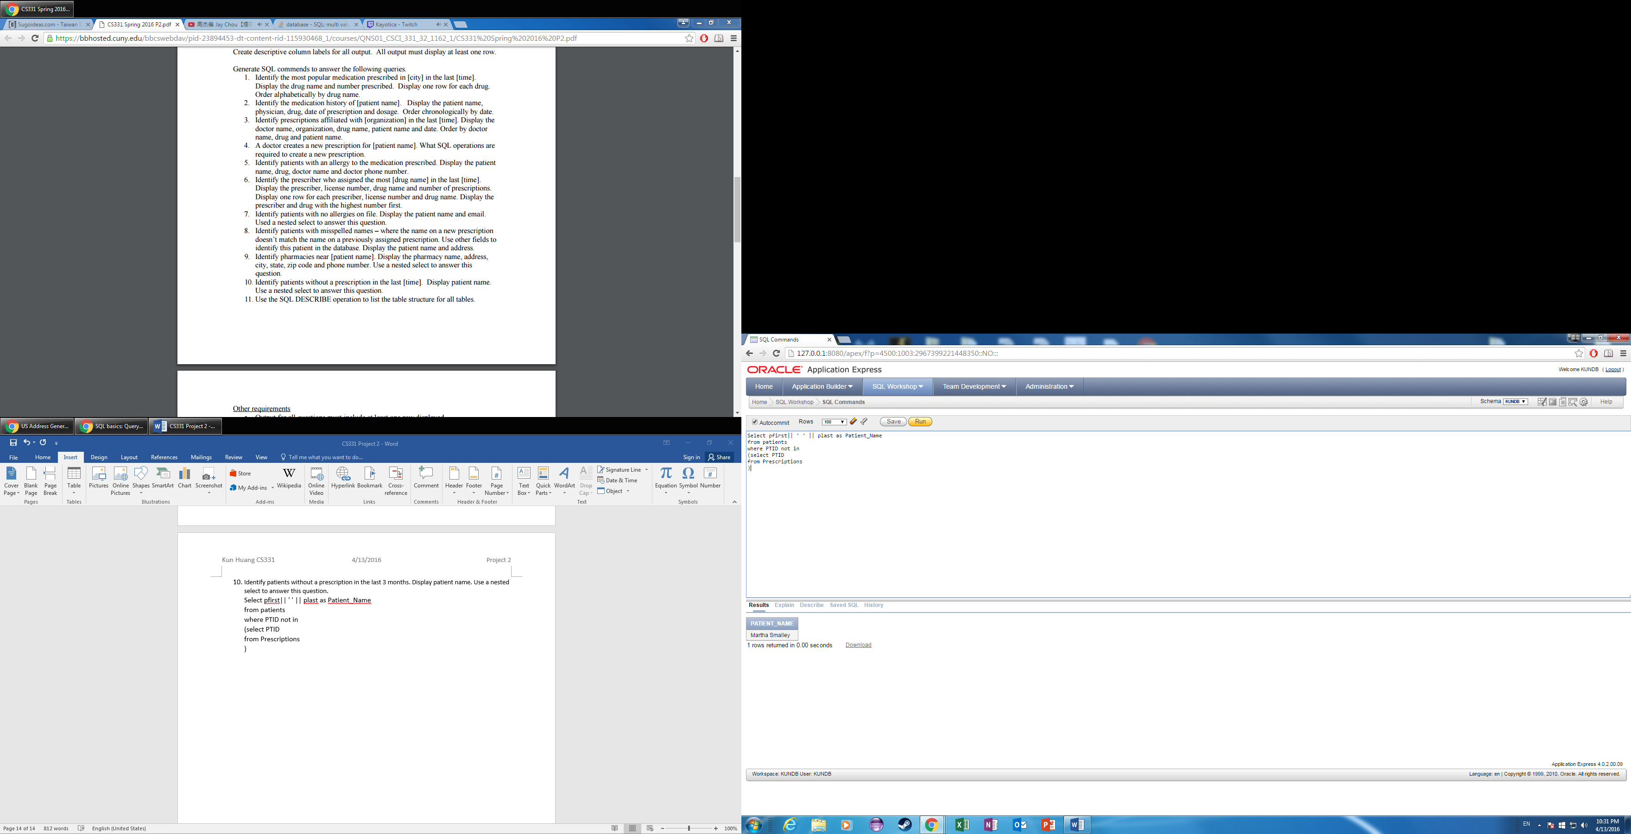

1. Use the SQL DESCRIBE operation to list the table structure for all tables.

describe organizations;

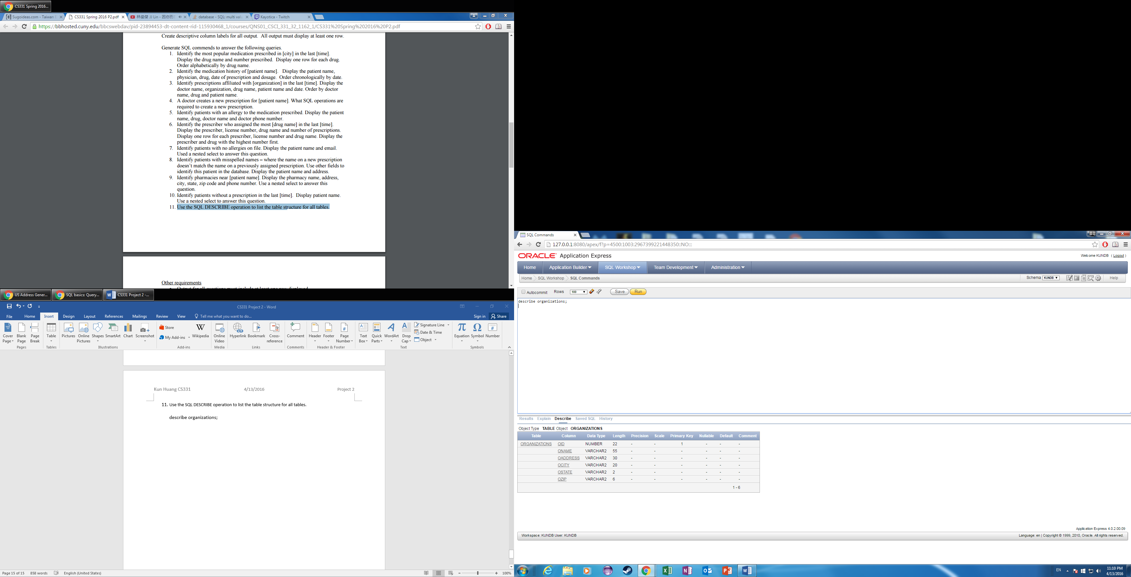

describe allergies

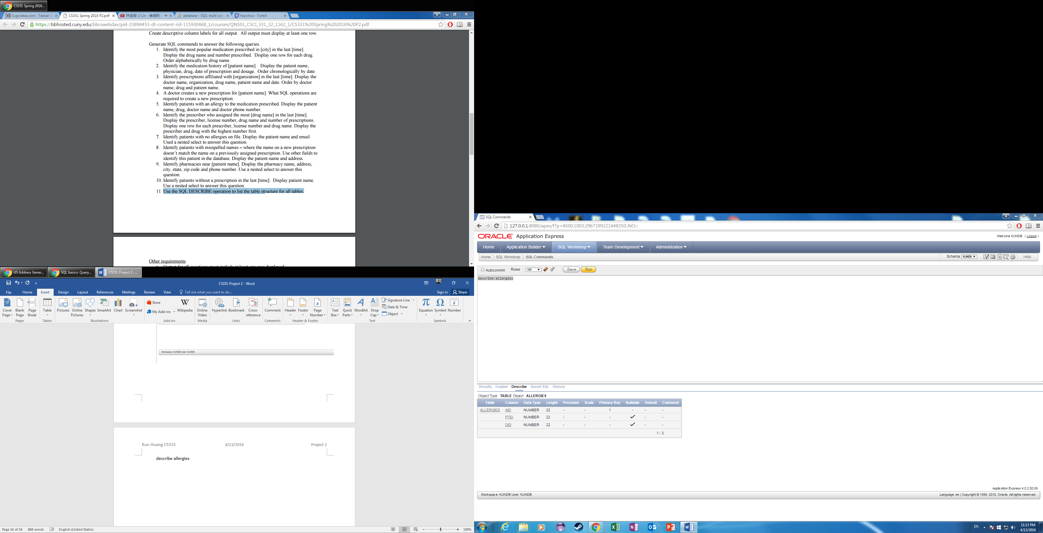

describe pharmacies

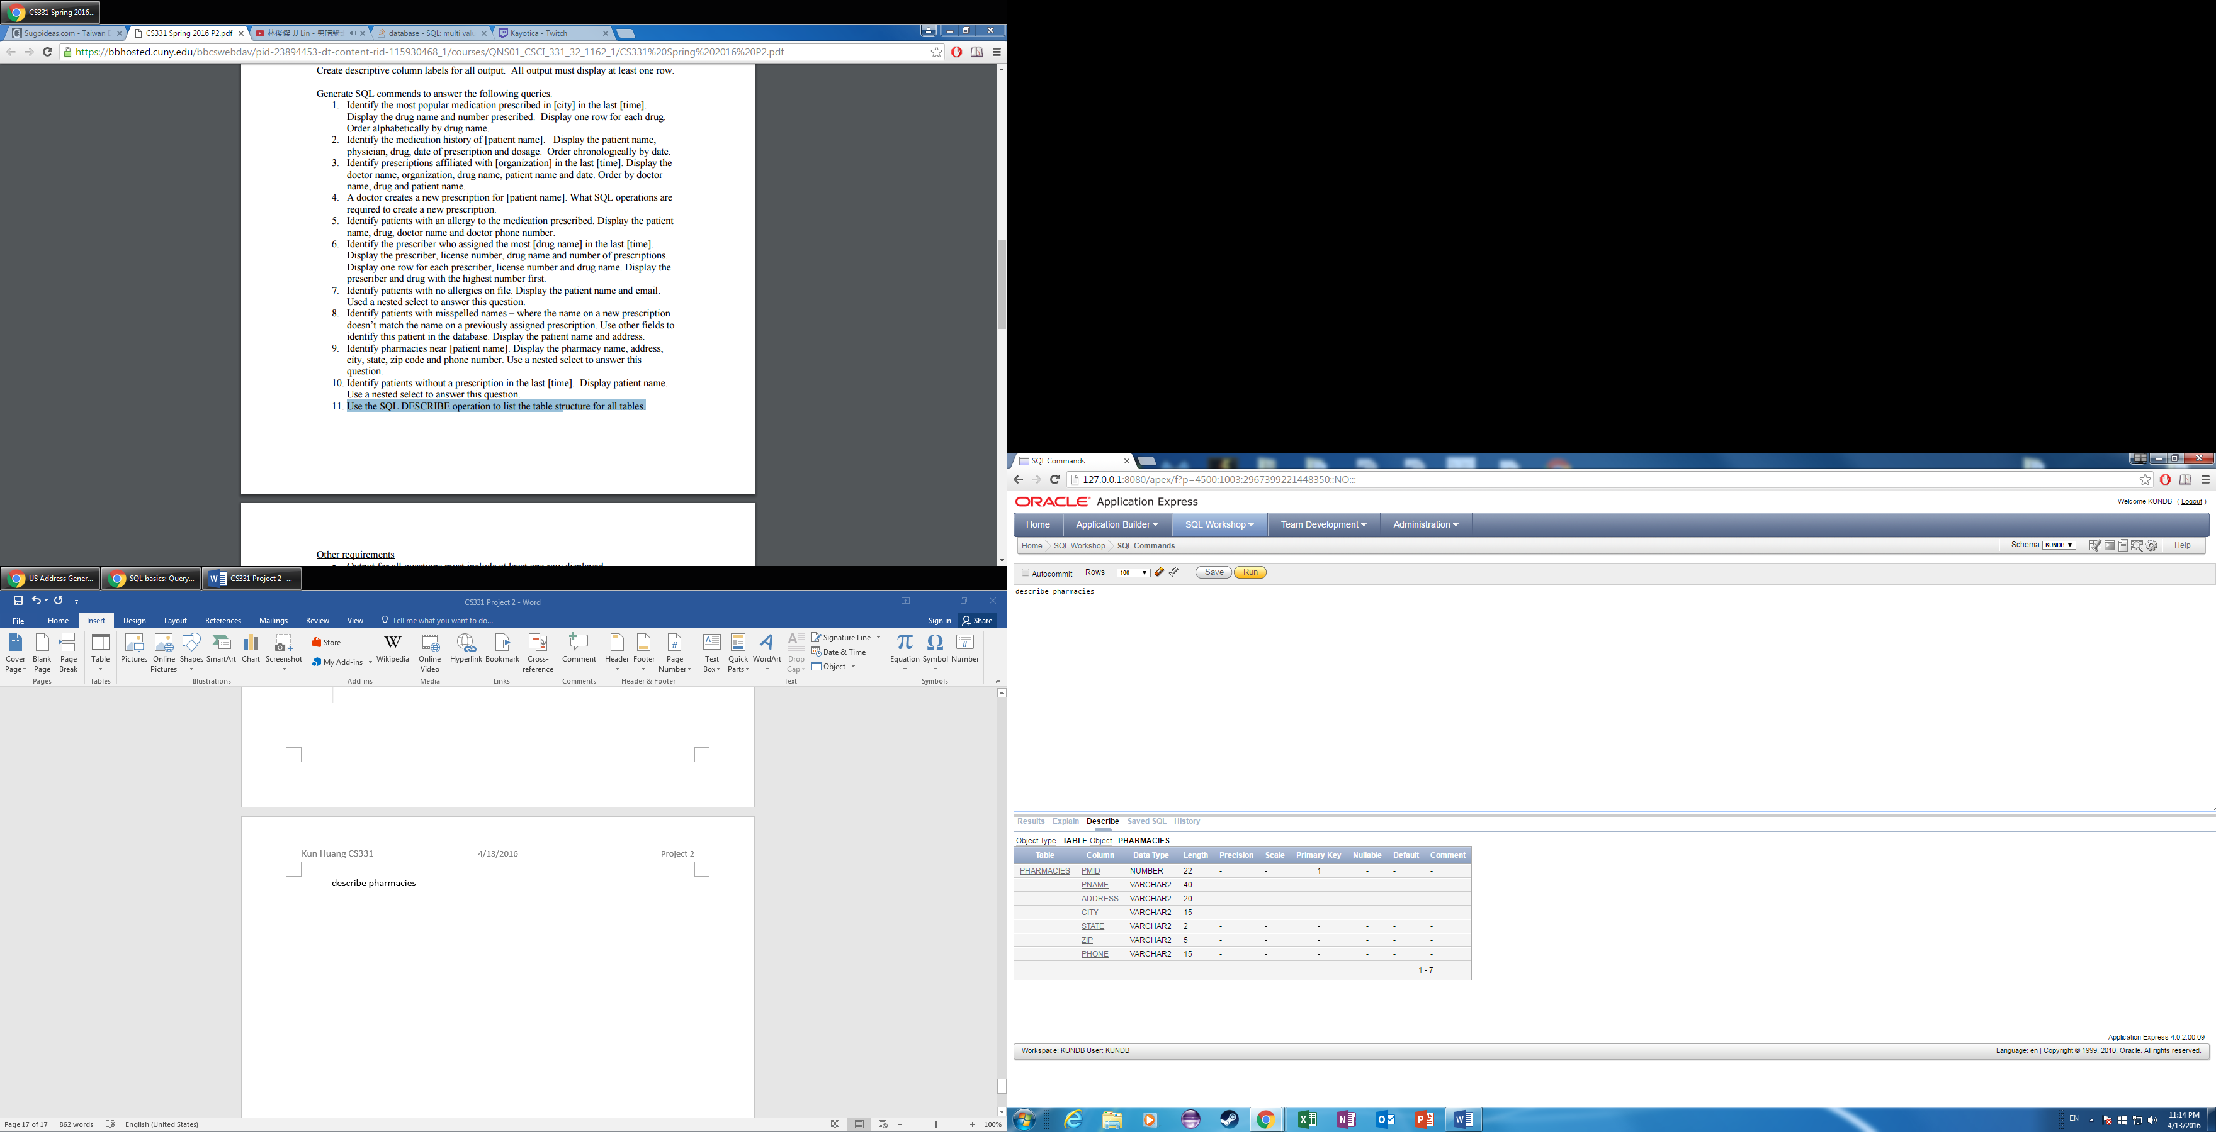

describe Patients

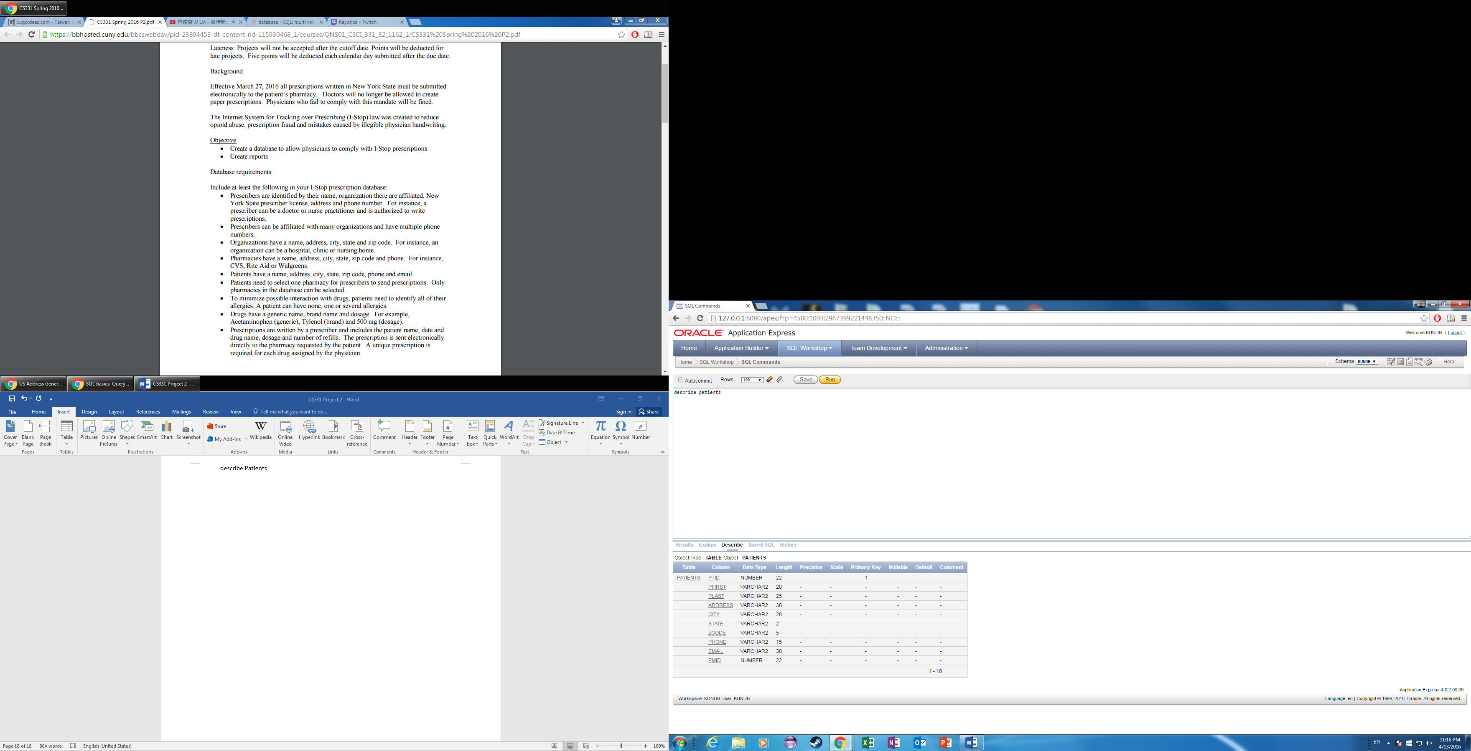

describe prescriptions

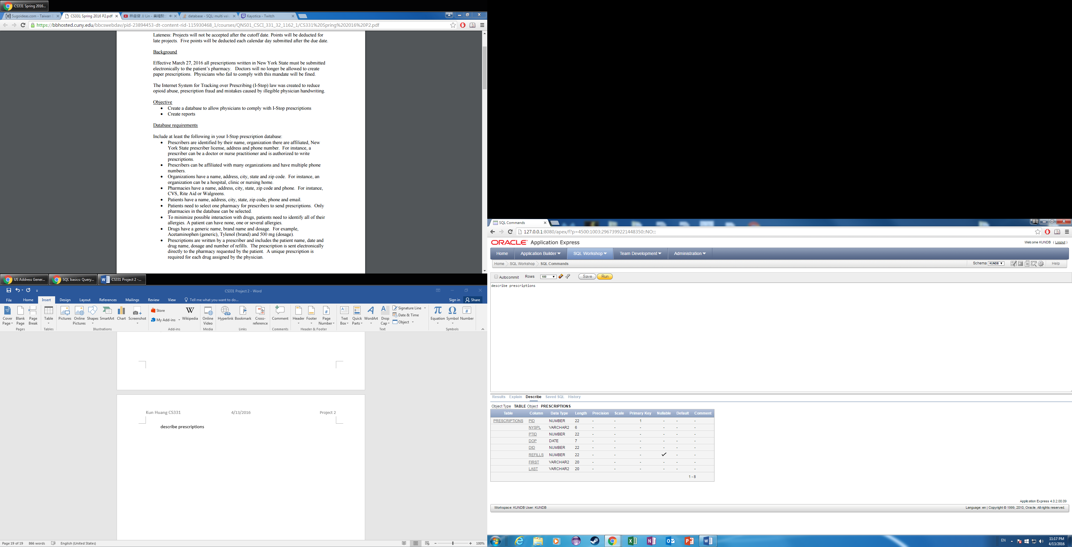

describe drugs

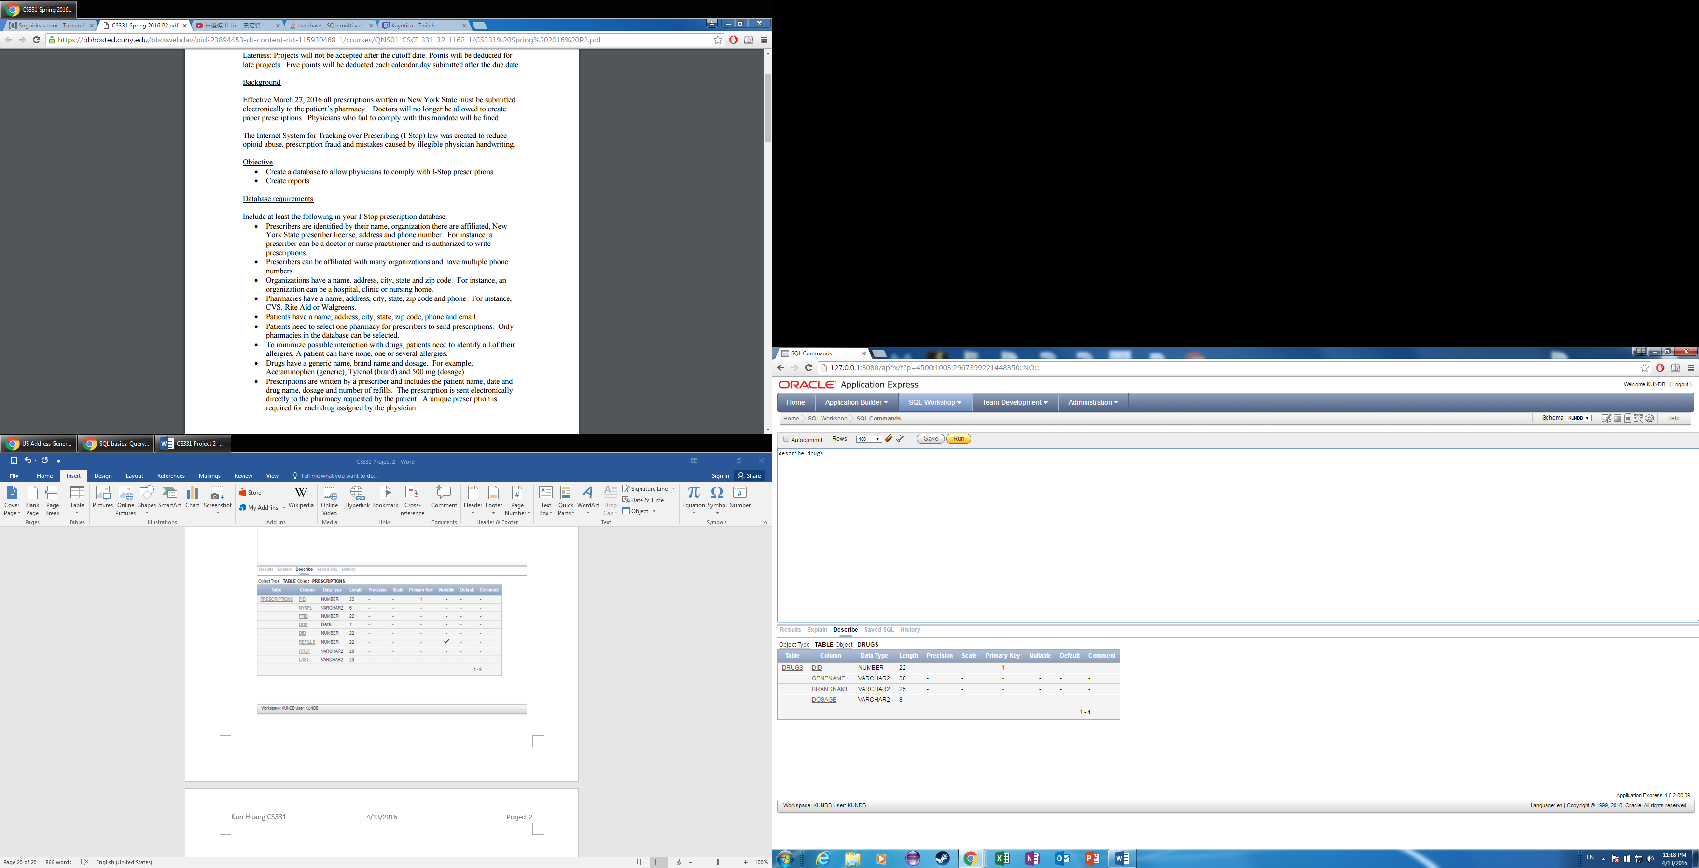describe prescribers

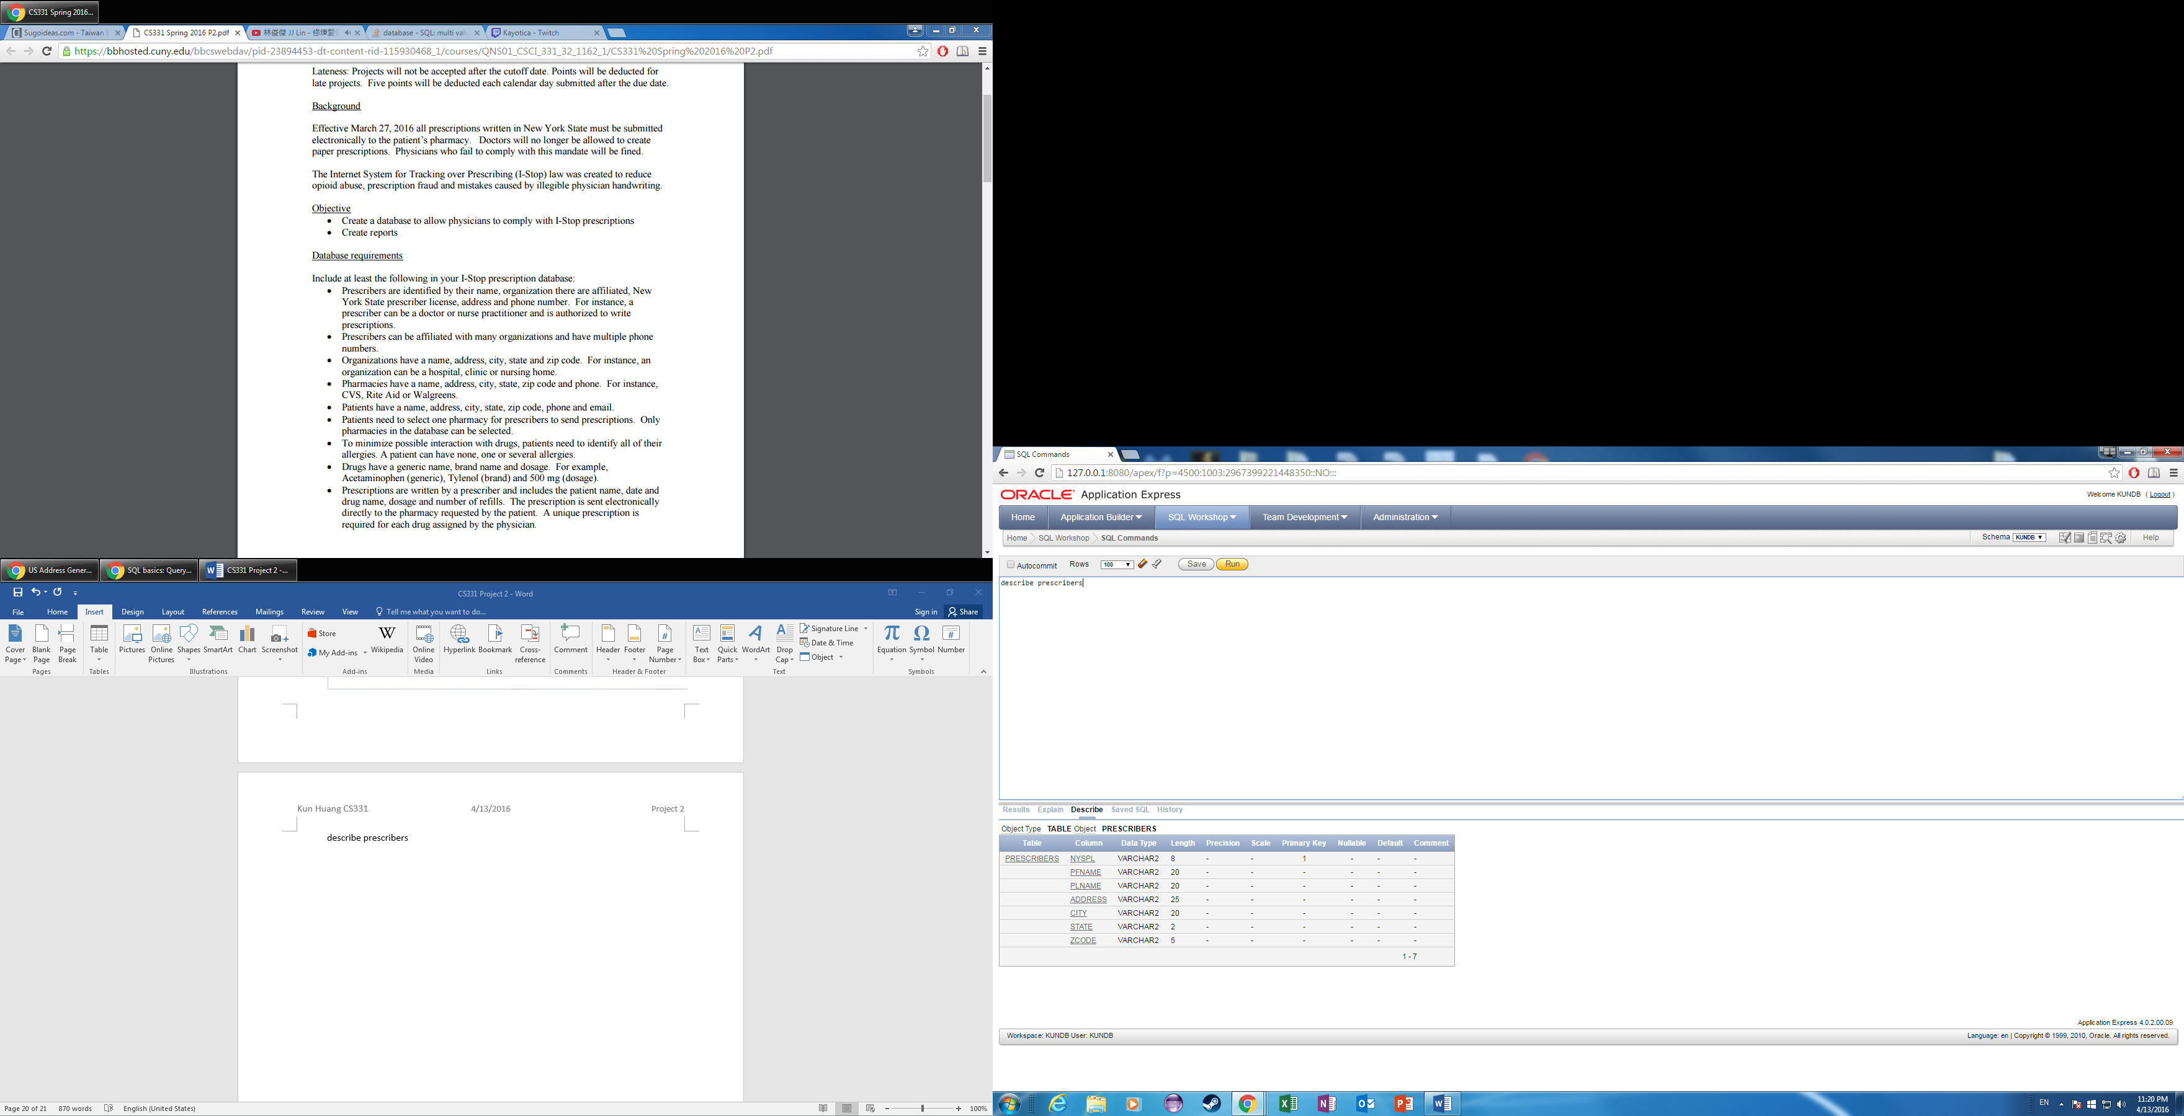

describe otype

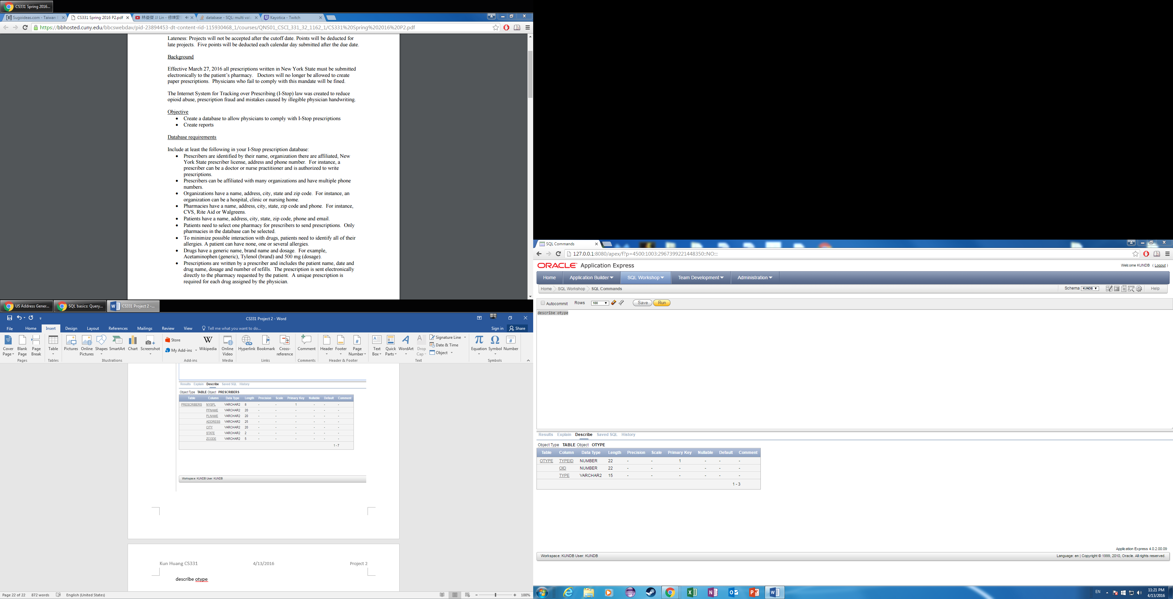

describe multiinfo

